Notice of Special Public Meeting of a Public Body

Section 7.6.2, 7.7.4, and 7.9.1

NOTICE OF CANCELLATION

OF REGULAR PUBLIC MEETING OF THE BOARD OF
HARVEST PREPARATORY ACADEMY

Pursuant to A.R.S. 38-431.02, notice is hereby given to the members of the board of Harvest Preparatory Academy and to the general public that the Harvest Preparatory Academy Board of Directors regularly meeting scheduled to be held on May 23, 2019 at 1748 S Arizona Avenue, Yuma, Arizona will be CANCELLED in accordance with school by laws and board policies and procedures.

Dated this 23rd day of May 2019

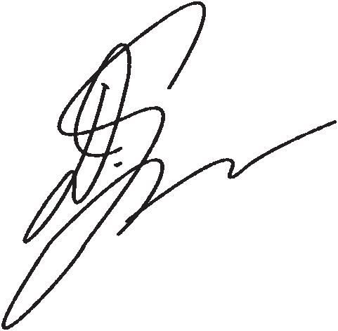
Harvest Preparatory Academy

By_________________________________
Debi Ybarra, President

