Notice of Public Meeting of a Public Body

Section 7.6.2, 7.7.4, and 7.9.1

NOTICE OF REGULAR MEETING OF THE
HARVEST PREPARATORY ACADEMY

Pursuant to A.R.S. 38-431.02, notice is hereby given to the members of Harvest Preparatory Academy and to the general public that the Harvest Preparatory Academy Board of Directors will hold a Board Meeting open to the public on December 19, 2019 at 10:00 a.m. located at 1748 South Arizona Avenue, Yuma, Arizona. If authorized by a majority vote of Harvest Preparatory Academy Governing Board, The Board of Directors of Harvest Power Community Development Group, Inc., the executive session will be held immediately after the vote and will not be open to
the public.

All public notices will be posted, as well as meetings held, at Harvest Preparatory Academy located at 1748 S. Arizona Avenue, Yuma, Arizona. Electronic notices will be posted on our website, at least 24 hours prior to each board meeting. Persons with disabilities or special accommodations may request a reasonable accommodation such as sign language interpreter or translator.

If you are unable to attend a meeting in person due to your geographical location, telephonic access can be arranged at our San Luis, AZ location (1040 N. 10th Ave) and Goodyear, AZ location (14900 N. Van Buren Street), by contacting Carissa Salas at 928-782-2052 ext. 4010. Requests should be made as early as possible to allow time to arrange for any accommodations.

Dated this 18th day of December, 2019

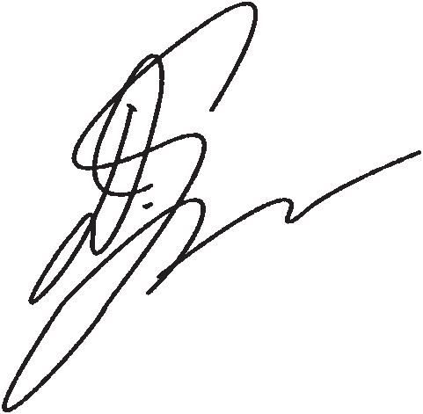
Harvest Preparatory Academy

By_________________________________
Debi Ybarra, President

