Notice of Public Meeting of a Public Body

Section 7.6.2, 7.7.4, and 7.9.1

NOTICE OF SPECIAL MEETING OF THE
HARVEST PREPARATORY ACADEMY

Pursuant to A.R.S. 38-431.02, notice is hereby given to the members of Harvest Preparatory Academy and to the general public that the Harvest Preparatory Academy Board of Directors will hold a Board Meeting open to the public on October 30, 2020 at 10:00 am located at 1748 S Arizona Avenue, Yuma, Arizona.

All public notices will be posted, as well as meetings held at Harvest Preparatory Academy located at 1748 S Arizona Avenue, Yuma, AZ 85364. Electronic notices will be posted on our website, at least 24 hours prior to each board meeting. Persons with disabilities or special accommodations may request a reasonable accommodation such as sign language interpreter or translator.

If you are unable to attend a meeting in person due to your geographical location, telephonic access can be arranged at our San Luis, AZ location (1040 N. 10th Ave), by contacting 928-782-2052 ext. 4029. Requests should be made as early as possible to allow time to arrange for any accommodations.

Dated this 29th day of October, 2020

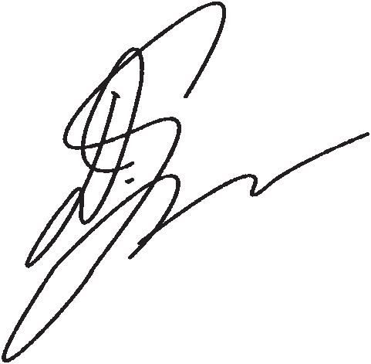
Harvest Preparatory Academy

By_________________________________
Debi Ybarra, President

