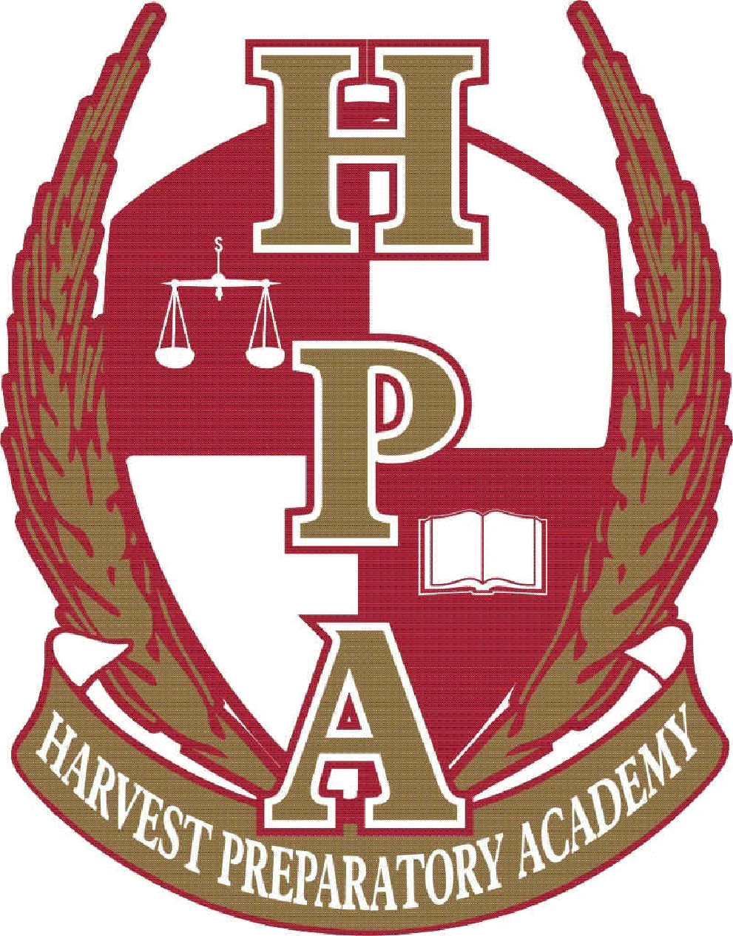

FIRST GRADE SUPPLY LIST
2024-2025

- 1 (2-inch) 3 ring binder with pockets
- 1 pkg (5-tab) different color plastic dividers with pockets
- 1 package of heavy-duty sheet protectors
- 2 wide ruled spiral notebook
- 1 Pencil pouch to go in binder (NO plastic tool boxes)
- 1 pack of #2 pencils (20 or more)
- 1 pack of 24 crayons
- 2 packs of colored pencils
- 1 pack of washable markers (large 8 count)
- 1 package of yellow highlighters
- 1 pair of headphones (NO wireless)
- 1 package of large black Expo dry erase markers (4 count)
- 4 glue sticks
- 1 pair of kid friendly scissors
- Backpack (no imagery considered inappropriate or offensive, such as violent or graphic content). NO WHEELS

The following items are for the entire classroom use.
- 1 box of tissues
- 1 ream of white copy paper
- 1 roll of paper towels
- 1 bottle of hand sanitizer
- 1 tub of Clorox wipes
- 1 package of baby wipes

**Additional items may be needed at different times of the year for certain projects in the classroom. Please replenish your child’s supplies as needed.

Thank you so much for your support!

The First Grade Teachers

